Quick Start Guide - IWMM Mobile App (IMA) - Version 2.0
Topic Directory (click bookmark to jump to that section)

Survey123 Application
Download Surveys
Complete and Submit Surveys
Save a Draft Survey
View and Clone Surveys
Data Sharing

ArcGIS Online (AGOL) Sign Up

Follow the steps below to Sign up for a new account if you do not already have one.

FWS Staff (i.e., @fws.gov email) Only—
- On your computer, go to http://fws.maps.arcgis.com/home/.

- Select “Sign In” in the upper right-hand corner.

- Select “U.S. Fish and Wildlife Service Account” option. You will automatically be logged into AGOL using single sign-on (SAML).
- Your user name is your FWS email address with “_fws” tagged onto the end (e.g., robert_fenwick@fws.gov_fws).
- Your password is your FWS active directory password.

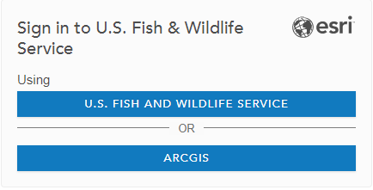

Important! - Once you have logged in for the first time, please email robert_fenwick@fws.gov to be added to the IWMM ArcGIS Online group. This will grant access to download the IMA 2.0 – Waterbird & Unit Condition Survey in Survey123. This step will only take a few minutes in most cases.
Survey123
The Survey123 application by ESRI is used to digitally record data collected in the field. Users must download a local copy of the IMA 2.0 – Waterbird and Unit Condition Survey while they have either WiFi or mobile data, fill out the survey on the iPad while in the field, and then submit the information once they again have an internet connection.

The Survey123 app can be downloaded from the Apple App Store on your tablet. For more information on Survey123, please visit http://doc.arcgis.com/en/survey123/.

Download Surveys to tablet—
- Open the Survey123 application on a mobile tablet while connected to Wifi or mobile data.

- You will be asked to sign in to ArcGIS Online (AGOL).

  - Click on ‘Enterprise Login’ at the bottom of the window 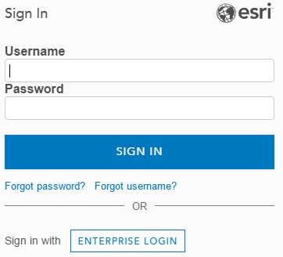
  - Type ‘fws’ into the text box and select ‘CONTINUE’
  - Select ‘U.S. Fish and Wildlife Service’
  - Enter your active directory credentials (full email address and AD password)

- Access downloadable surveys either by clicking on the ‘Get Surveys Now’ button (This will only show up if no other surveys have been downloaded on your device), or by clicking the three lines in the top right of the screen, then “Download Surveys’.
- Select IMA 2.0 to download from options available in the Download Surveys window by tapping on the Download icon . Choosing the Refresh icon on an already downloaded survey will replace the locally-saved survey with the latest update.

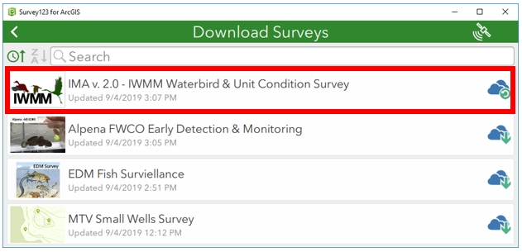

Important! - A project must already exist or be created in the AKN database to give your survey data a place “to land” upon upload. Check the Data Catalog to see if a project for your station already exists. If no project is found, use the new project form to submit your request to the IWMM database administrator who will create your project, assign a project code, and notify you when the process is complete.

Complete and Submit Surveys—
- Select the back arrow to return to the My Surveys gallery on the device.

- Select IMA 2.0 – Waterbird & Unit Condition Survey to open it.
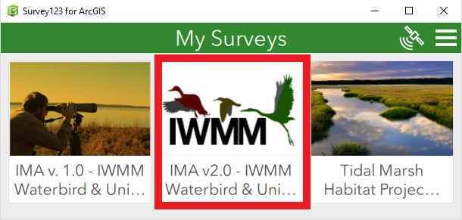
- Tap on Collect to start entering information into the survey. Because the survey has been downloaded onto the device, data can be collected while offline.

- Select your project and sampling unit(s) to complete the survey according to the IWMM protocol. Additional guidance can be found in ServCat HERE. Please see the Data Formatting Instructions for additional guidance.

- Once data collection is complete, proceed to the record summary on the third page of the form to review and edit entries as necessary.
- Following review, submit the survey by tapping on the check mark in the lower right-hand corner of the application (see next page).

- Select Send Later if the survey is not complete or if there is no WiFi or cellular service. This survey will remain in the Outbox until manually submitted by the user (no automatic submission).

- Select Send Now to submit the survey to AGOL if you have an active WiFi connection..

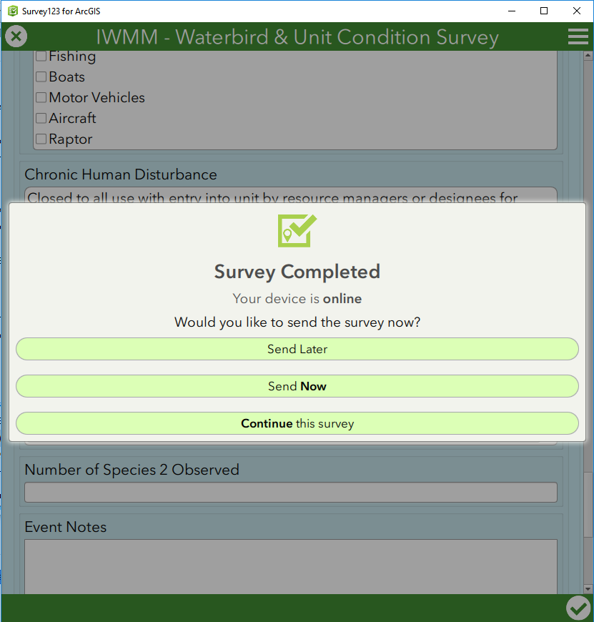

Exit and Save a Draft Survey—
- While collecting data with a survey open, tap the “X” at the top left of the survey screen. This will prompt you to select one of the three options below:
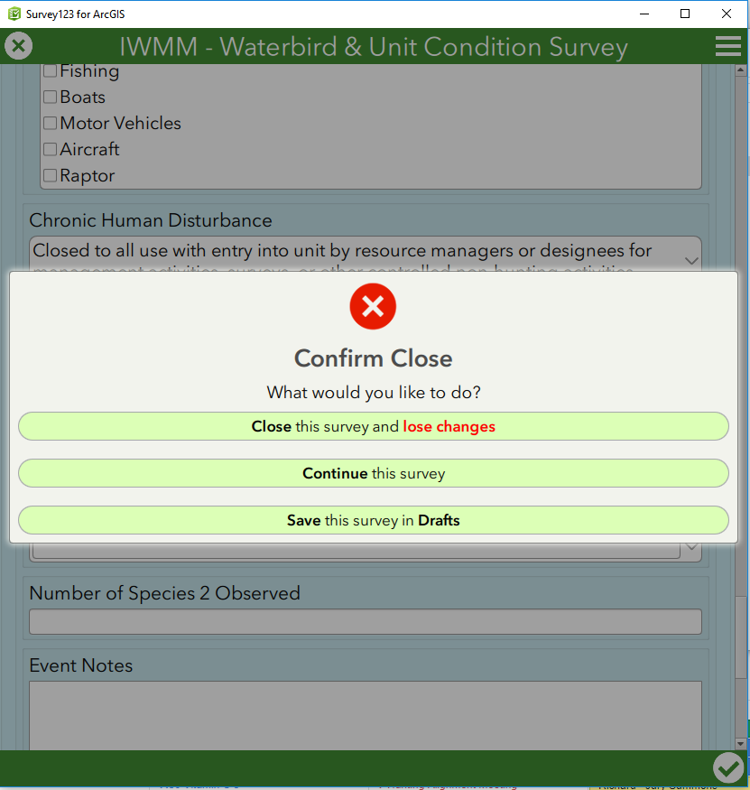

- If a Draft is saved, you will be able to access and continue this survey at a later time from the “Drafts” box on the home screen:
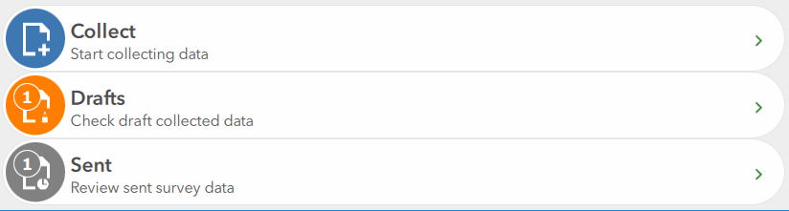

View and/or Clone Previously Submitted Surveys—
- You can view and even clone submitted surveys on your iPad through your Sent box.

- You will see a list of all of the surveys that have previously been submitted under your user name on this device. Tapping a survey will open the options below. Choose the “Edit” option to review survey information.
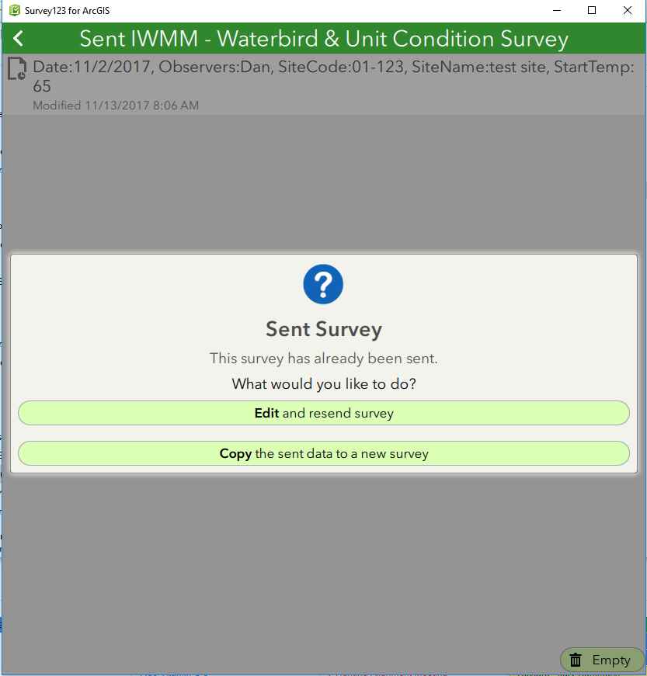

Note: Survey edits are best accomplished in the app PRIOR to submitting the survey. The record summary on page 3 of the form provides the ability to quickly review your data for errors prior to sending. Records should be as complete and correct as possible prior to transmission. Once data has arrived in AKN, the last step in the survey process is to use the IWMM portal to conduct a final review of the data, make any final edits, and then promote the data to the desired sharing level.

- For cloning, choose a survey to clone, and select “Copy the sent data to a new survey”. Please note that ALL fields in the cloned survey will already be populated, so review and edit each field carefully before submitting as a new survey.

Data transfer to Point Blue —
Data submitted using the app goes first to ArcGIS online (AGOL). Survey data must then undergo a transfer process in order to populate in the AKN data management system. An API has been developed to automate this process and render survey data sent from the app every 24 hours.
Sharing Data with other Users—
Important! - Survey data will be submitted to the AKN at a sharing level of ‘Raw’. You are REQUIRED to access your data via the IWMM database portal to review and promote your data to the proper sharing levels. See the Help guide for information about this process.

While it is recommended that data be promoted to sharing Level 5, at a minimum all data must be promoted to sharing Level 2 in order to contribute to regional and national analysis. Proper data sharing is necessary to support regional management actions and overall health of waterbird populations.

For more information on AKN sharing levels or IWMM’s sharing policy, please refer to the IWMM program website at http://iwmmprogram.org/protocols-data-forms/.

