Quick Help 9: Adding Sampling Units to a Project (IWMM)
Objective: Users with IWMM data in the Avian Knowledge Network data management system (AKN) will learn how to create a study area and associated management units for their project.
Audience: Current, registered IWMM users with Project Leader access to a Project in the AKN.

Step 1. Log in to the IWMM Portal
Before logging in, make sure that your Project has been created in the AKN and that an IWMM protocol has been assigned to it. You will not see your Project in the IWMM portal until you have assigned a valid IWMM protocol to it. For help with assigning protocols, please refer to the AKN Quick Help Guide 4 in ServCat.
IWMM participants that have registered for an account in the AKN and have been assigned to a Project with Project Leader permissions may create and manage units for their Project(s) all within the IWMM portal. Start by logging in to the portal and selecting your Project from the Select Site (Project) drop down menu.
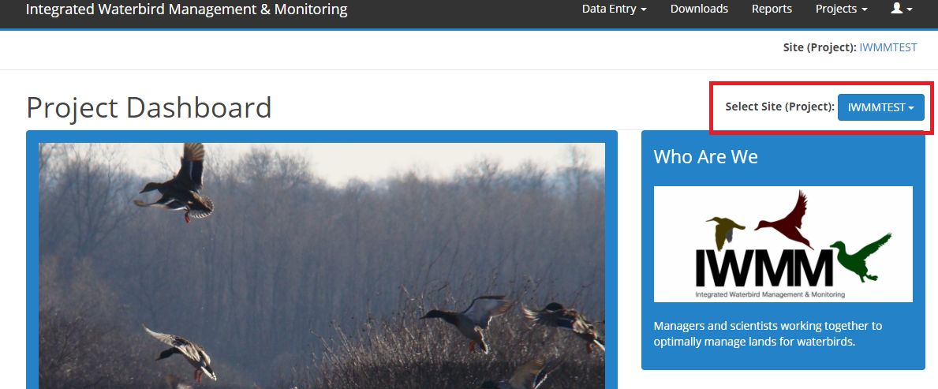
With your Project selected, hover over the Projects tab and select Manage Units.
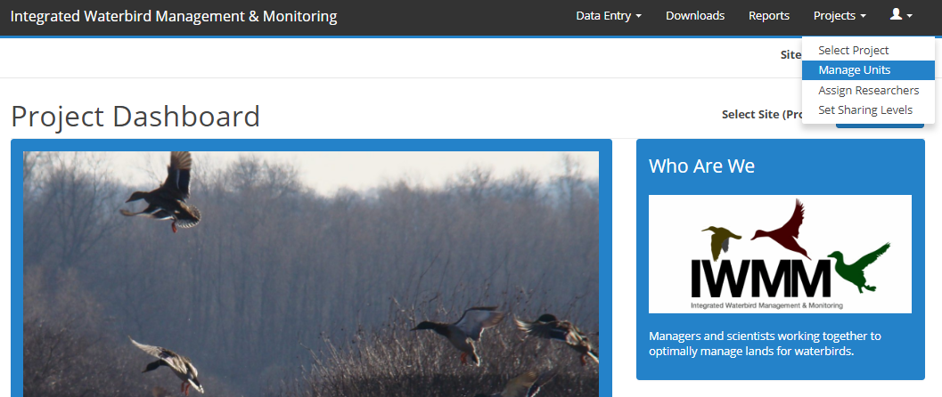

Step 2. Create a Study Area
Before creating individual management units, the first step is to create a study area. In the AKN, the study area provides a folder for independent studies or protocols that are being utilized by a Project. Within a study area there may be one or many management units. Since multiple protocols may be assigned to one Project (e.g., landbird or marsh bird), IWMM study areas are given a short name code to better identify them as specific to IWMM. To obtain a short name code for your study area, contact the IWMM Coordinator.
Start by clicking on the Project’s name in the sampling unit tree (it will highlight yellow). Select online form underneath the Add Sampling Units under the highlighted feature section.
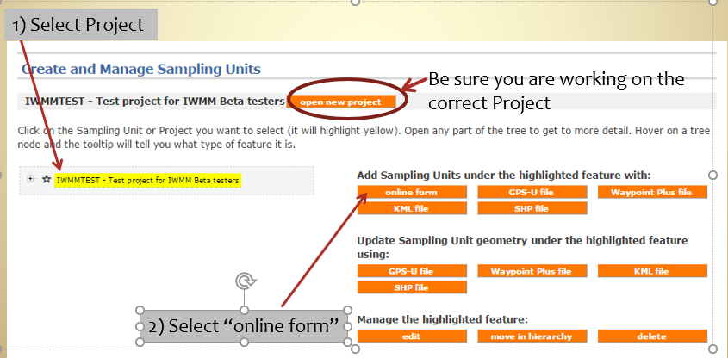
Select Study Area (Area) from the list provided. Check that you are creating a study area ‘As part of’ No other study area and click enter.
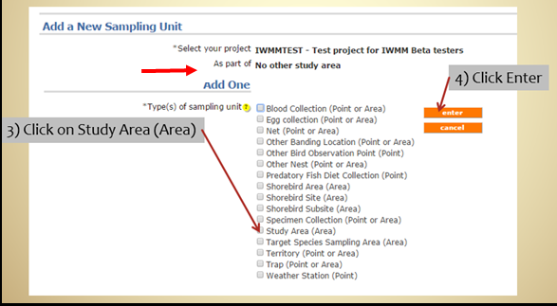
Assign a “long” name to the study area. This is typically the name of the Refuge or official name of the study area (e.g. Occoquan Bay NWR). If you haven’t already, contact the IWMM Coordinator to obtain a “short” name for the study area. Provide a description for the study area that will be meaningful for current and future individuals interested in this Project’s data. When you are finished, click save.
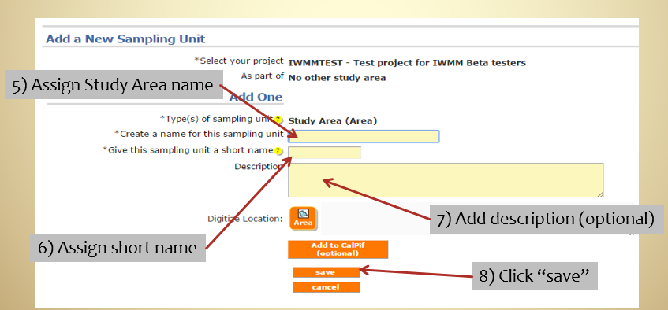

Step 3. Create Management Units
Start by clicking on the study area name in the sampling unit tree (it will highlight yellow). Select online form underneath the Add Sampling Units under the highlighted feature section.
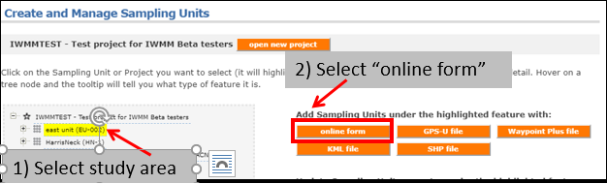
Check to see that you are creating a management unit ‘As part of’ Your Study Area. Select IWMM Management Unit (Area) from the list provided. Click enter when you are ready.
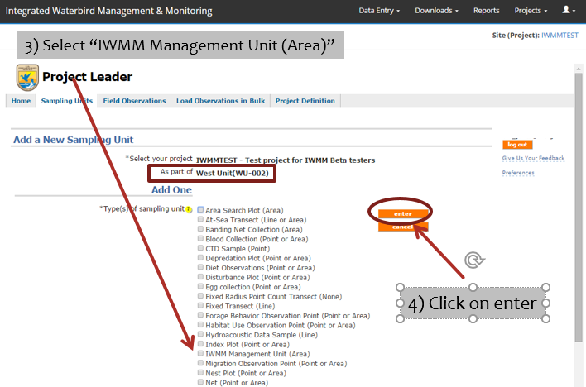
Assign a “long” name to the unit – use something meaningful to current and future staff. If you haven’t already, contact the IWMM Coordinator to obtain a “short” name for the unit. When you are finished, click save. Repeat this process for all other management units under the IWMM study area.
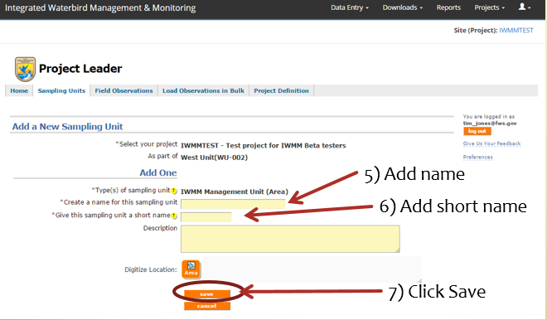

Step 4. Input Spatial Data
Spatial data may be entered via two ways: digitizing over imagery or uploading GIS files (KML, KMZ, or ArcGIS Shapefile). Regardless of the method you choose, all spatial data must use the WGS84 datum.
  - Digitizing sampling unit boundaries
From the sampling unit tree, select the study area or management unit you are interested in to add spatial information ( it will highlight yellow) and click edit.
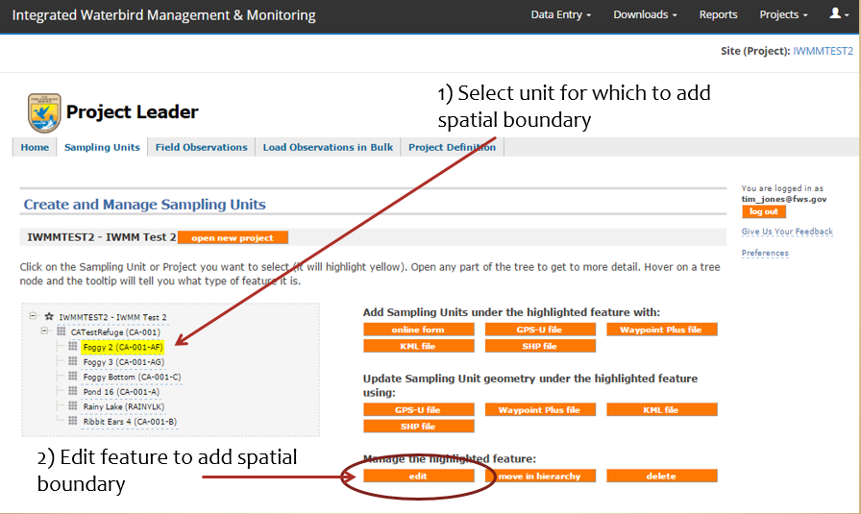
This will take you to the Google map screen where you will zoom into your Project area and digitize your unit or study area. Left click around boundary of unit to assign vertices. Once complete, click keep it to save edits.
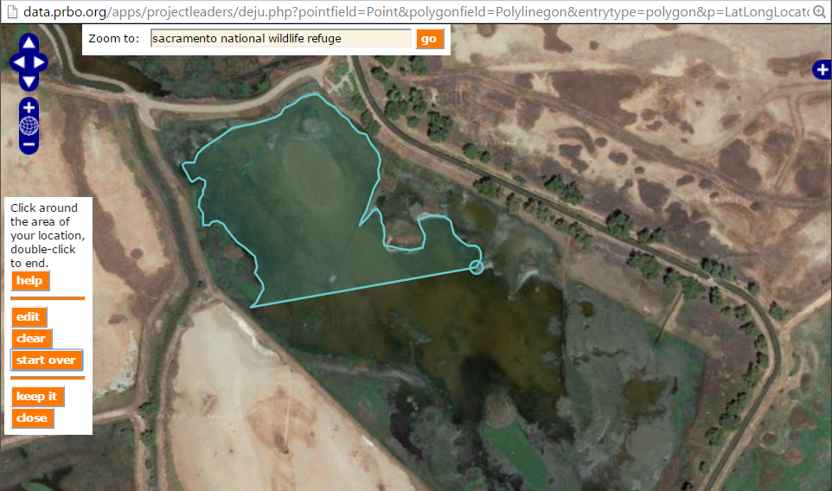
  - Uploading boundaries via files
From the sampling unit tree, select the study area or management unit you are interested in to add spatial information (will highlight yellow) and click on the appropriate file type.
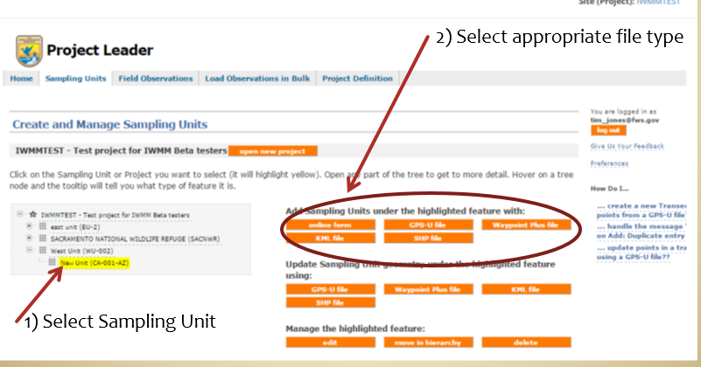
Confirm that you are adding spatial information for the correct project and unit. Click Choose File to browse to the local file and click IWMM Management Unit (Area). Add a prefix and suffix for each long name. This will generate a sample unit “template” for each polygon that is found in the uploaded file. For example, if you type “Chincoteague” for the prefix and “IWMM” for the suffix and upload a file with three units identified, the polygons would be named Chincoteague_001_IWMM, Chincoteague_002_IWMM and Chincoteague_003_IWMM. When you are finished, click next.
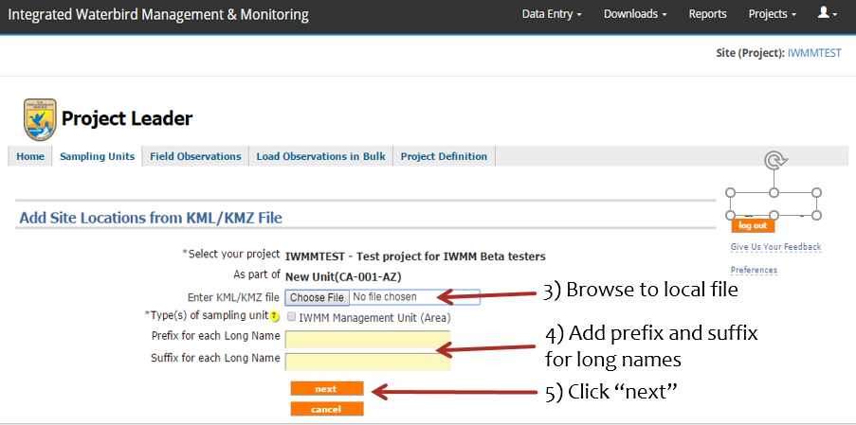
Select unit(s) from imported file. When finished, confirm that your unit(s) uploaded correctly. Repeat this process for any additional units.
